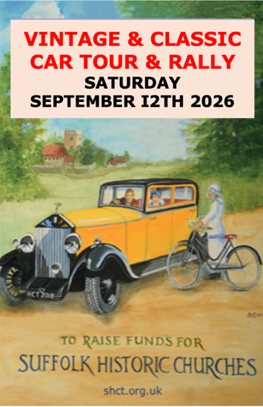
PEDAL & DRIVE
CAR RALLY
2026 ENTRY
FORM

WE DO HOPE YOU DECIDE TO JOIN US ON SATURDAY SEPTEMBER 12th 2026. AND PLEASE ENCOURAGE FRIENDS WITH OTHER GLORIOUS CARS TO JOIN US. AS EVER IT SHOULD BE A UNIQUE & FUN OUTING.

TO ENTER, COMPLETE THIS FORM & SCAN BOTH PAGES to pedalanddrive@gmail.com OR POST IT TO PEDAL & DRIVE c/o HIGH PALE, SUDBURY ROAD, BURES, SUFFOLK CO8 5JP.

Surname: First Name(s):…………………….

Vehicle type & date of first registration :

Number Plate:

Car Club membership (if any):

How/from whom did you hear about the Rally?:

Driver’s Address & postcode:

Email address:

Mobile No :

By signing this form I give my permission for the Suffolk Historic Churches Trust to hold the above details and to contact me by email or post with further communications about this Rally and other future events.

Signature_____________________________________________ Date _______________

ENTRY DETAILS
- ENTRY FEE
You can pay your £45 entry fee either electronically to ‘Suffolk Historic Churches Trust – Ride and Stride’ at CAF Bank Ltd Sort Code 40-52-40 Acc No 00035164 quoting “P&D & your name” as the reference please; or enclose a cheque made out to ‘Suffolk Historic Churches Trust – Ride and Stride’ with this form.
- DONATION
With escalating building costs and the Lottery ceasing to ringfence funds for places of worship, times have been tough for those who care for our wonderful church buildings. If you wish to make an additional donation to the work of the Suffolk Historic Churches Trust, you can do so either by adding a sum to your fee payment as above or by separate CAF voucher (you cannot use CAF for the Entry Payment). We would be grateful if you could add Gift Aid to your donation by printing and signing the following Gift Aid form

Charity Gift Aid Declaration
Boost your donation by 25p of Gift Aid for every £1 you donate. Gift Aid is reclaimed by the charity from the tax you pay for the current tax year. Your address is needed to identify you as a current UK taxpayer.

I want to Gift Aid my donation of £______________ to Suffolk Historic Churches Trust
I am a UK taxpayer and understand that if I pay less Income Tax and/or Capital Gains Tax in the current tax year than the amount of Gift Aid claimed on all my donations it is my responsibility to pay any difference.

Signature_____________________________________________ Date _______________

Please notify the charity if you: want to cancel this declaration; change your name or home address; no longer pay sufficient tax on your income and/or capital gains. If you pay Income Tax at the higher or additional rate and want to receive the additional tax relief due to you, you must include all your Gift Aid donations on your Self-Assessment tax return or ask HM Revenue and Customs to adjust your tax code
The Suffolk Historic Churches Trust is an entirely volunteer organisation & 99% of what you give will go to the fabric of Suffolk’s wonderful array of churches & chapels.
- CHOICE OF START POINT Please show your
1st choice start point: ………………..……………………and
2nd choice start point:…………………….…………..
Elveden Hall (Thetford), Grove Park (Yoxford. Halesworth), Denston Hall (Newmarket), Langham Hall (Bury St Edmunds), Great Bevills(Sudbury), Tattingstone Place (Tattingstone Ipswich)

